**Lesson 4 Visual Line Following Integration with micro:bit**

# Preparation

Connect WonderCam to micro:bit Expansion Board Port 4.

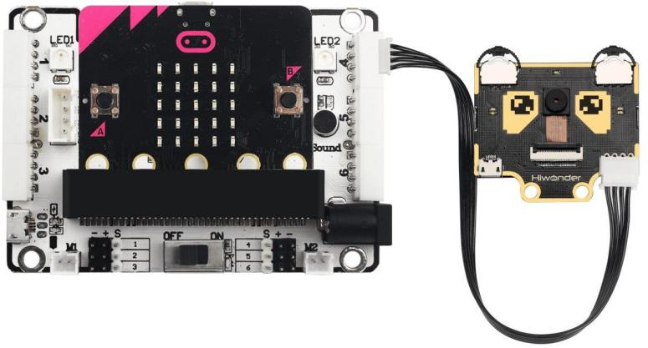

# Learning Objective

1. To know the connectivity of WonderCam on micro:bit Expansion Board.
2. To understand the program logic.

# Programming Plan

In this lesson, we will integrate the Vision module Visual Line Following function with the output from micro:bit Expansion Board. The program will first initialize the Vision module following by detecting the line and present it on the micro:bit Dot Matric Display.

# Programming

## Adding Extension

Go to <https://makecode.microbit.org/> and create New Project. In the MakeCode Toolbox, select Advanced, click on Extensions to add the following two extension packs:

<https://github.com/hiwonder/wondercam>

<https://github.com/Hiwonder/Startbit>

## Command Blocks

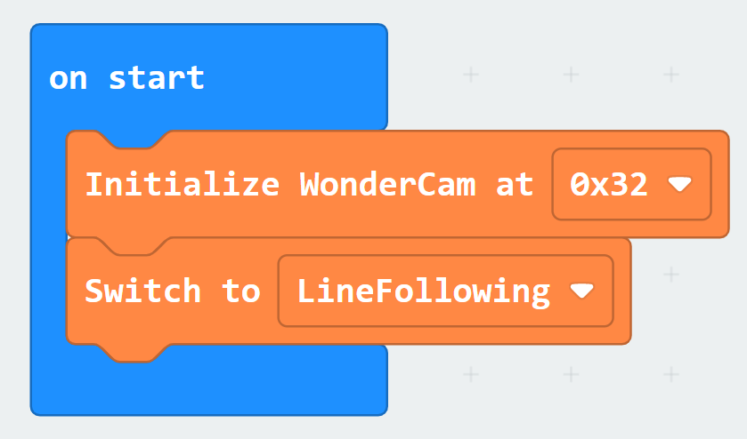

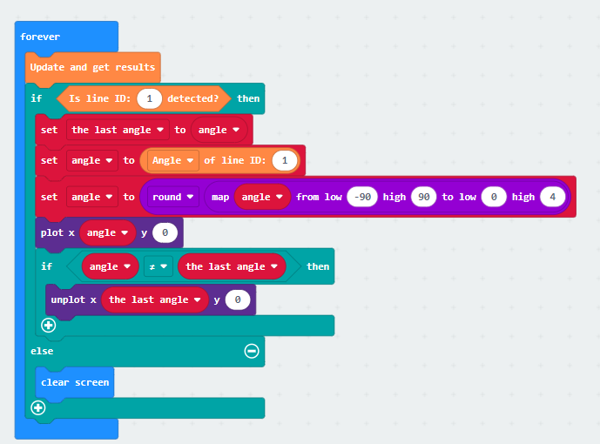

4.1 Pairing devices and program download

1. Connect micro:bit to computer.

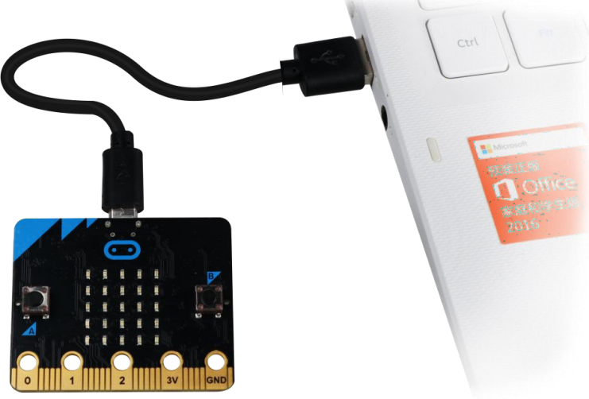

1. Click on “…” located beside“Download” and select “Pair device”.

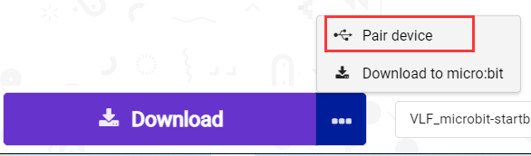

1. Click on on “Pair device” on the Pop-up screen.

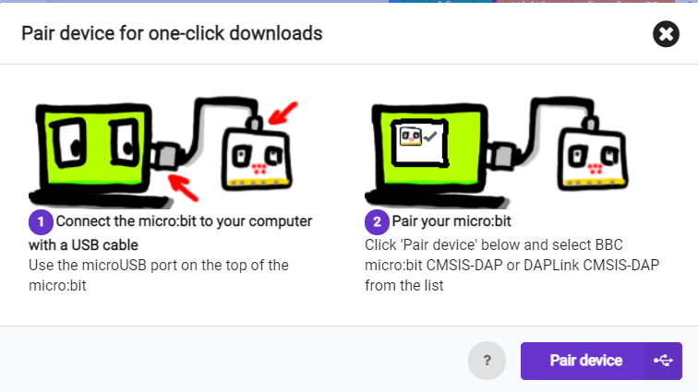

1. Click “Connect” as shown in image below.

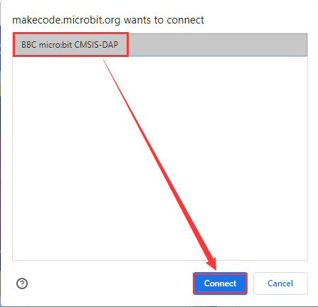

1. Once connection is successful,click “Download”. During downloading process, the yellow light on micro:bit will blink consistently, do not disconnect or change USB cable.
2. When download is finished, the light on micro:bit will remain on and screen will appear.

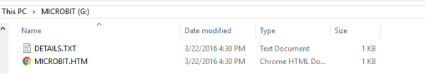

Tips: In micro:bit drive there are two files as show in image above. DETAILS.TXT

records the data information of the micro:bit board. MICROBIT.HTM links to micro:bit official web page (computer need to be online when click).

# Results

**\***Please refer to Lesson 4 Visual Line following on how to program Line recognition.

After program is downloaded, connect micro:bit to Expansion board and switch power to ON. WonderCam will automatically start on Visual Line Following function.

Start by Learning Line ID1. When Line ID1 is recognized, an LED Lights on micro:bit display board will light up move accordingly to the direction of line detected.